**Задание 1.**

1. Is an authorized federal executive authority?

2. What duties and functions is the Federal Customs Service carrying out?

3. Who is the Federal Customs Service being managed and directed by?

4. Who shall the Federal Customs Service be guided in conducting its activity by?

5. What shall the Federal Customs Service carry out its activities through?

**Задание II. Переведите на английский язык:**

1. Одной из важнейших обязанностей таможенника является предотвращение провоза контрабанды.

2. Незаконный ввоз и вывоз валюты, ценных бумаг, ювелирных изделий, антикварных вещей и т.д. рассматривается как контрабанда.

3. Незадекларированные предметы обычно задерживаются, и пассажир может получить их на обратном пути.

4. Предметы, сокрытые от таможенного контроля, считаются контрабандой и могут быть конфискованы.

5. Лицо, нарушившее таможенные правила, подлежит наказанию в соответствии с Таможенным кодексом.

6. Таможенный инспектор иногда может произвести личный досмотр, если у него есть основания полагать, что пассажир имеет при себе предметы, подлежащие изъятию.

7. Обычно личный досмотр производится с разрешения начальника таможни и в присутствии двух понятых.

8. Протокол личного досмотра подписывается инспектором, понятыми и досматриваемым лицом.

9. В случае конфискации вещей или ценностей составляется протокол задержания предметов контрабанды, который подписывается обвиняемым.

10. Решение суда является окончательным и обязательным к исполнению.



**Задание III. Для каждого предложения выберите соответствующее время глагола, данного в скобках:**

1. If I ___ you, I would apologize to her right away. (to be)

2. If I run into her, I ___ her that you’re looking for her. (to tell)

3. If you ___ that again, I will call the police. (to do)

4. He would never have asked her out on a date if she ___ him first. (to kiss)

5. If you were her, what ___? (to do)

6. If she hadn’t gone to England, she ___ Orlando Bloom. (to meet)

7. If it doesn’t start snowing, we ___ this evening. (to go skiing)

8. If you had saved some money earlier, you ___ broke right now. (to be)

9. If I ___ at the airport so late, I would not have missed my flight. (to arrive)

10. If you buy one t–shirt, you ___ the second one free (to get).

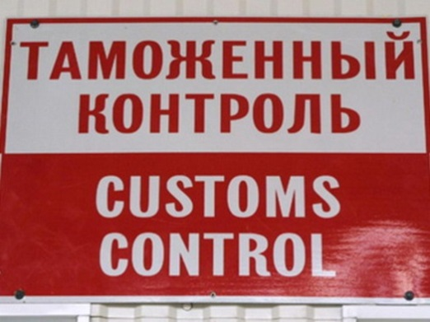

**Задание IV. Для каждого предложения выберите соответствующее время глагола, данного в скобках:**

1. I ___ (take) a shower when you called.

2. My brother ___ (have) never been to Europe until he went there last year.

3. Diane ___ (feel) very sick but she decided to go out anyway.

4. He ___ (call) her all night.

5. I ___ (want) to go swimming but the water was too cold.

6. I ___ (be) able to sleep well for a week now.

7. When I first saw her, she ___ (stan d) on the balcony.

8. Really? You moved to a new apartment? How long ___ (live) there?

9. Every time I see that movie, it ___ (make) me cry.

10. I ___ (stop) smoking three years ago.

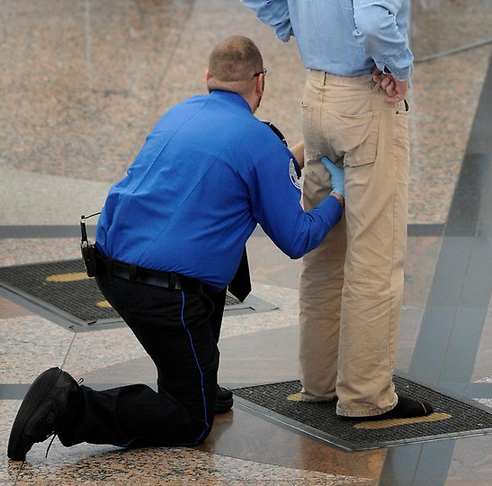

**Задание V. Для каждого предложения выберите соответствующее время глагола, опираясь на предложенные варианты:**

1. If she hadn’t told him, he ___.

a) will never find out b) would have never found out

2. I ___ this is you hadn’t asked me.

a) would never have done b) didn’t do

3. If I ___ about this, I would have told you.

a) know b) had known

4. If they ___ to rest they would not have been so tired.

a) have stopped b) had stopped

5. I ___ that he’s 38 years old if he hadn’t told me.

a) wouldn’t have guessed b) didn’t guess

6. If I hadn’t seen that movie last week, I ___ to see it with you yesterday.

a) would go b) would have gone

7. If you ___ the money that you owe me, I would have been able to go out

last night.

a) had returned b) returned

8. Thomas wouldn’t have bought the jacket if it ___ on sale.

a) hadn’t been b) wouldn’t be

9. If you ___ me, I wouldn’t have known about the party.

a) haven’t called b) hadn’t called

10. Tina would have called you if you ___ her your number.

a) would give b) had given

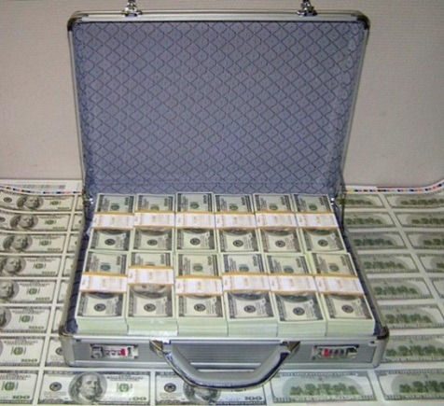

**Задание VI. Для каждого предложения выберите соответствующее время глагола, опираясь на предложенные варианты:**

1. “He will come tomorrow. ” She told me that he ___ tomorrow.

a) is coming b) will come c) would come

2. “I see the clouds. ” He told me that she ___ the clouds.

a) sees b) is seeing c) saw

3. “My mother is taking the bus to work tomorrow. ” He told me that his

mother ___ the bus to work tomorrow.

a) is taking b) was taking c) will take

4. “I will call you. ” I told her that I ___ her.

a) will call b) would call c) would have called

5. “I have been there. ” She told me that she ___ there.

a) had been b) has been c) was

6. “I will be studying tomorrow. ” I told him that I ___ tomorrow.

a) will be studying b) would be studying c) will study

7. “Open the window!” He asked me ___ the window.

a) to open b) open c) opened

8. ”I am happy. ” She told me that she ___ happy.

a) has been b) is c) was

9. “I have seen that movie. ” He told me that he ___ that movie.

a) had seen b) will have seen c) has seen

10. “I am flying to India tomorrow. ” He told me that he ___ tomorrow.

a) is flying b) was flying c) will fly

**Задание VII. Для каждого предложения выберите соответствующее время глагола, опираясь на данный пример:**

JOHN: “Go away!” John told us to go away.

1. MRS. SMITH: “Don’t play in front of my window!” Mrs. Smith told us ___

2. YOUR MOTHER: “Come back in one hour. ” Your mother told me ___.

3. TOM: “Call me in the evening. ” Tom told us ___.

4. YOU: “Come with us!” They told Mary ___.

5. HEATHER: “Don’t say that!” HEATHER told you ___.

6. GEORGE: “Feed the cat!” GEORGE asked his girlfriend ___.

7. MR. STEPHENS: “Buy me some milk!” Mr. Stephens told me ___ some milk.

8. VICTORIA: “Leave me alone!” Victoria told her friend ___ alone.